**NAME:_________________________________ALGEBRA 2 COMMON CORE**

**TEST Review**

Find the average rate of change over the interval [0,4].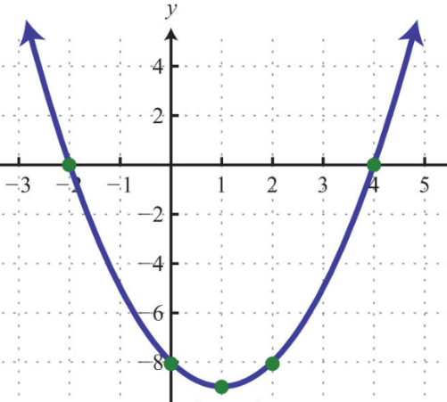

Let $h\left(x\right)=5x+2, p\left(x\right)=\frac{1}{3}x-3, and q\left(x\right)=-2x+4.$ Find $\left(h ∘p \right)\left(18\right).$

Find the vertex of the quadratic equation, $y=\frac{1}{11}{\left(x-9\right)}^{2}+27.$

Find a quadratic regression for the data below which represents the average rainfall per year for Rochester, NY. Let $x=0$ represent $1985$. *(round to the nearest thousandth)*

|  |  |  |  |  |  |  |  |  |
| --- | --- | --- | --- | --- | --- | --- | --- | --- |
| Year | 1985 | 1990 | 1995 | 2000 | 2005 | 2010 | 2015 | 2018 |
| Rainfall | 39” | 37.8” | 34.3” | 30.1” | 28” | 34.4” | 36” | 40.1” |

What type of solutions does the quadratic equation $3x^{2}-9x+16=0$ have?

1. real, irrational, unequal
2. real, rational, unequal
3. real, rational, equal
4. imaginary

What is the simplified form of $\left(2+\sqrt{-81}\right)-(-4-\sqrt{-1} )$

Solve 3 $x^{2}-9x-17=0$ for $x$, algebraically.

Write the equation of the circle in standard form, then identify the center of the circle and radius.

$${3x}^{2}+{3y}^{2}+6x-24y+30=0$$

Write an equation of a parabola with a focus of $\left(-1, 2\right)$ and a directrix of $y=4.$

1. State the vertex.
2. Write the equation of the parabola.
3. Sketch the parabola.

Solve each of the following by factoring. Show all work.

1. $4x^{2}-24x=0$ b. $2x^{2}-x-10=0$

Graph on axes below. Label the solution set **S**.

$y≤x^{2}-2x-8$

State the coordinates of ONE point in the solution set **S**: __________

Solve the system of three equations and three unknowns.

|  |  |  |  |  |  |  |  |
| --- | --- | --- | --- | --- | --- | --- | --- |
|  | *x* | + | *y* | − | *z* | = | 4 |
|  | | | | | |  |  |
|  | *x* | − | 2*y* | + | 3*z* | = | −6 |
|  | | | | | |  |  |
|  | 2*x* | + | 3*y* | + | *z* | = | 7 |

